Name_______________________________________

Topics 1 and 2 Review

Consider the infinite geometric sequence .
- Write down the 10th term of the sequence. Do not simplify your answer. [1]
- Find the sum of the infinite sequence. [4]
- Let 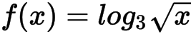 , for 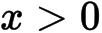 .
- Show that 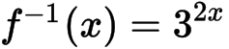 . [2]
- Write down the range of 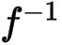 . [1]
- In a geometric series, 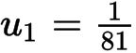 and 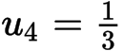.
- Find the value of . [3]
- Find the smallest value of n for which 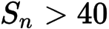 . [4]
- The first three terms of an arithmetic sequence are 5 , 6.7 , 8.4 .
- Find the common difference. [2]
- Find the 28term of the sequence. [2]
- Find the sum of the first 28 terms. [2]
5a. Expand 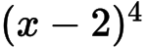 and simplify your result. [3]
- Find the term in 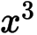 in 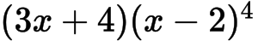 . [3]
- The first term of a geometric sequence is 200 and the sum of the first four terms is 324.8.
- Find the common ratio. [4]
- Find the tenth term. [2]
7. Let 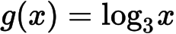 , for . Find the value of 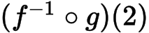 , giving your answer as an integer. [4]
8. Let , for .
a. Show that 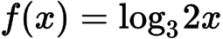 . [2]
b. The function f can also be written in the form 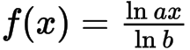 . [6]
(i) Write down the value of a and of b .
(ii) Hence on graph paper, sketch the graph of f , for 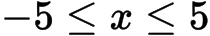 , 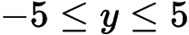 , using a scale of 1 cm to 1 unit on each axis.
(iii) Write down the equation of the asymptote.
- Find the value of 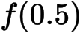 and of 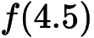 . [3]
- Write down the value of 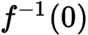 . [1]
- The point A lies on the graph of f . At A, 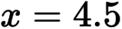 . On your diagram, sketch the graph of , noting clearly the image of point A. [4]
9. Consider the expansion of .
a. Find b. [3]
b. Find k. [3]
10. Consider the expansion of 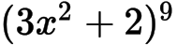 .
a. Write down the number of terms in the expansion. [1]
b. Find the term in 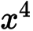 . [5]
11. Let 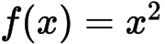 and 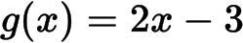 .
a. Find 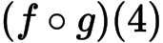 . [3]
b. Find 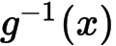 . [2]
12. Let 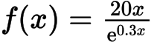 , for .
a. Sketch the graph of f . [3]
b. [3] (i) Write down the x-coordinate of the maximum point on the graph of f .
(ii) Write down the interval where f is increasing.
- Show that 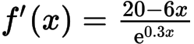 . [5]
- Find the interval where the rate of change of f is increasing. [4]
13. Let 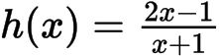 , 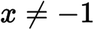 .
a. (i) Sketch the graph of h for 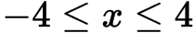 and 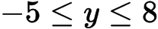 , including any asymptotes.
(ii) Write down the equations of the asymptotes.
(iii) Write down the x-intercept of the graph of h . [7]
- Find 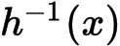 . [4]
c. Let R be the region in the first quadrant enclosed by the graph of h , the x-axis and the line .[5]
(i) Find the area of R.
(ii) Write down an expression for the volume obtained when R is revolved through 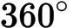 about the x-axis.
14. Let 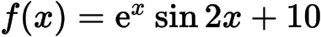 , for 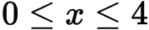 . Part of the graph of f is given below.
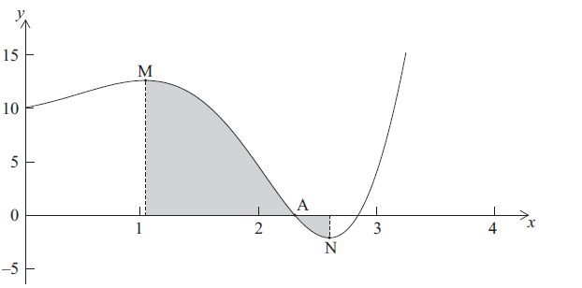
There is an x-intercept at the point A, a local maximum point at M, where and a local minimum point at N, where .
- Write down the x-coordinate of A. [1]
b. Find the value of [2]
(i) p ;
(ii) q .
- Find 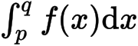 . Explain why this is not the area of the shaded region. [3]
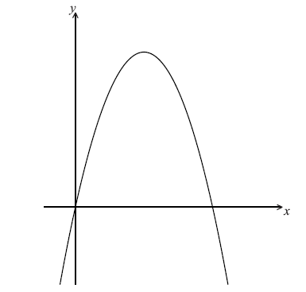
15. Let 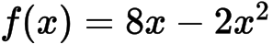 . Part of the graph of f is shown below.
a. (i) Write down the equation of the axis of symmetry.
(ii) Find the y-coordinate of the vertex. [3]
- Find the x-intercepts of the graph. [4]

16. Let 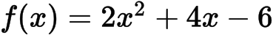 .
a. Express 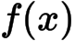 in the form 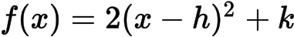 . [3]
b. Write down the equation of the axis of symmetry of the graph of f . [1]
c. Express in the form 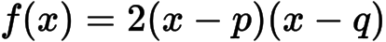 . [2]
17. Consider the equation 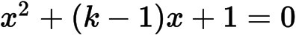 , where k is a real number.
Find the values of k for which the equation has two equal real solutions. [7]
18. Solve 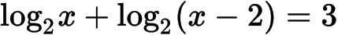 , for 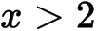 . [7]

Printed for East Mecklenburg High School
© International Baccalaureate Organization 2015
International Baccalaureate® - Baccalauréat International® - Bachillerato Internacional®

