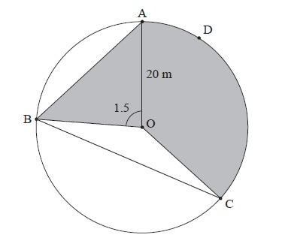
Name______________________________

Topic 3 Review
- The following diagram shows a circular play area for children.

The circle has centre O and a radius of 20 m, and the points A, B, C and D lie on the circle. Angle AOB is 1.5 radians. Angle BOC is 2.4 radians.
- Find the length of arc ADC. [3]
- Find the length of the chord [AB]. [3]
- Find the area of triangle AOB. [2]
- Find the area of the shaded region. [3]
- The shaded region is to be painted red. Red paint is sold in cans which cost 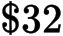 each. One can covers 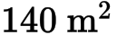. How much does it cost to buy the paint? [4]

- Let 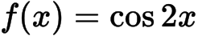 and 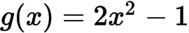 .
- Find 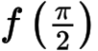 . [2]
- Find 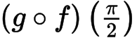 . [2]
- Given that 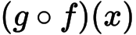 can be written as 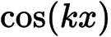 , find the value of k, 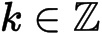 . [3]

- Let 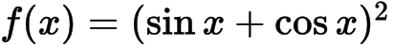 . Show that 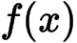 can be expressed as 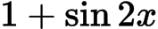 . [2]

- The diagram below shows part of the graph of , where 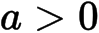 .
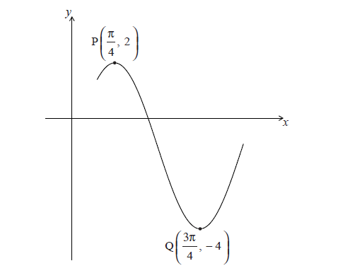
The point 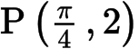 is a maximum point and the point 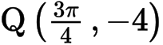 is a minimum point.
- Find the value of a . [2]
- (i) Show that the period of f is .
(ii) Hence, find the value of b . [4]
- Given that 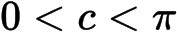 , write down the value of c . [1]

- Let 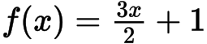 , 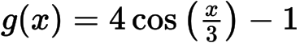 . Let 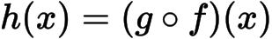 .
- Find an expression for 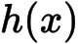 . [3]
- Write down the period of . [1]
- Write down the range of . [2]

- a. Show that . [2]
b. Hence, solve the equation for 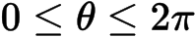 . [5]

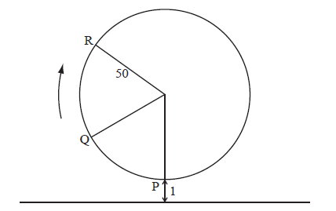
7. The following diagram represents a large Ferris wheel at an amusement park.
The points P, Q and R represent different positions of a seat on the wheel.

The wheel has a radius of 50 metres and rotates clockwise at a rate of one revolution every 30 minutes.
A seat starts at the lowest point P, when its height is one metre above the ground.
- Find the height of a seat above the ground after 15 minutes. [2]

- After six minutes, the seat is at point Q. Find its height above the ground at Q. [5]

The height of the seat above ground after t minutes can be modelled by the function .
- Find the value of b and of c . [6]

- Hence find the value of t the first time the seat is 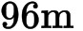 above the ground. [3]

8. Consider the following circle with centre O and radius r .
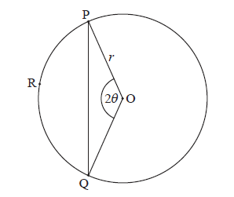
The points P, R and Q are on the circumference, 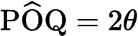 , for 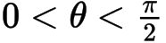 .
- Use the cosine rule to show that 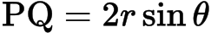 . [4]
- Let l be the length of the arc PRQ . Given that 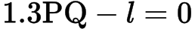 , find the value of . [5]
- Consider the function 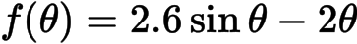 , for . [4]
(i) Sketch the graph of f .
(ii) Write down the root of 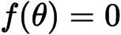 .
- Use the graph of f to find the values of for which 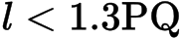 . [3]

9. Consider the triangle ABC, where AB =10 , BC = 7 and = 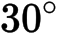 .
- Find the two possible values of . [4]
- Hence, find 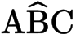 , given that it is acute. [2]

Printed for East Mecklenburg High School
© International Baccalaureate Organization 2015
International Baccalaureate® - Baccalauréat International® - Bachillerato Internacional®

