IB Math Studies

Review Sheet for Chapter One: Number and Algebra

You should be able to do the following things on the test:

Classify numbers as real, irrational, rational, integer, prime, and/or natural. Section 1.1
Express any decimal as a rational number in the form , where a and b are integers Section 1.1
Arrange numbers in any form in increasing or decreasing order Section 1.1
Round any answer to a requested number of significant figures Section 1.2
Round any answer to a requested number of decimal places Section 1.2
Find the percent error between an exact answer and an approximate answer Section 1.2
Write any number in standard form Section 1.3
Perform operations with numbers in standard form Section 1.3
Perform operations involving metric units and conversions [i.e. m² cm²] Section 1.4
Perform operations involving time units and conversions [i.e. hours seconds] Section 1.4

From previous knowledge, you should also know how to:

Solve any linear equation for x
Use geometric formulas for perimeter, area, and volume
Use the formula d = rt [distance = rate x time]

For review, complete the problems on pages 34-37
and/or the problems that follow

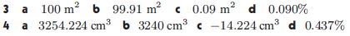
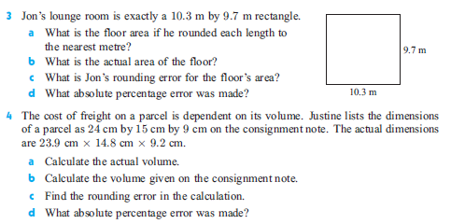

IB Math Studies

Review Problems for Chapter One: Number and Algebra

