Topic 7: Introductory Calculus

Chapter 6: Introducing Differential Calculus

Time Frame: Weeks 13 to 18

Day 1: A 17 6.1 Introduction to Differentiation

Day 2: A 19 6.2 The Gradient Function

Day 3: A 25 6.2 The Gradient Function

Day 4: A 27 6.3 The Gradient of a Curve at a Given Point
Day 5: A 2 6.4 The Tangent Line
Day 6: A 4 6.4 The Normal Line
Day 7: A 8 6.5 Rates of Change
Day 8: A 10 6.6 Local maximum and minimum points
Day 9: A 12 6.7 Modeling with Calculus
Day 10: A 6 6.7 Modeling with Calculus
Day 11: A 8 6.7 Modeling with Calculus
Day 12: A 12 Test on Calculus
Day 13: A 15 Error Analysis of Test

Math Analysis / IB Math Standard

Review Sheet for Chapter 6: Introducing Differential Calculus

You should be able to do the following things on this test:

Draw tangent lines on curves Section 6.1
Understand the derivative as the gradient [rate of change] of a function Section 6.1
Find the gradient of a line between two points on a function and compare it
to the gradient at a given point on a function. Section 6.1
Describe a gradient as increasing, decreasing, or zero Section 6.1
Use the power rule to find the first derivative $\left(f^{'}\left(x\right) \text{or} \frac{dy}{dx}\right)$of a function Section 6.2
Find the gradient of a curve for a given value of x Sections 6.2 & 6.3
Find values of x when $f^{'}\left(x\right)$ is given Sections 6.2 & 6.3
Find the tangent line to a curve for a given value of x Section 6.4
Find the normal line to a curve for a given value of x Section 6.4
Apply differential calculus to real-life problems involving rates of change Section 6.5
Use the derivative to identify the intervals where a function is increasing ($f^{'}\left(x\right)>0)$ Section 6.6
Use the derivative to identify the intervals where a function is decreasing $(f^{'}\left(x\right)<0)$ Section 6.6
Use the derivative to identify the horizontal tangent lines to a function ($f^{'}\left(x\right)=0)$ Section 6.6
Use the derivative to identify all maximum and minimum points of a function $(f^{'}\left(x\right)=0)$ Section 6.6
Use differential calculus to model and solve optimization problems
* perimeter, area, volume, surface area, height, cost, etc... Section 6.7

Math Analysis / IB Math Standard

Review Sheet for Chapter 6: Introducing Differential Calculus

You should be able to do the following things on this test:

Draw tangent lines on curves Section 6.1
Understand the derivative as the gradient [rate of change] of a function Section 6.1
Find the gradient of a line between two points on a function and compare it
to the gradient at a given point on a function. Section 6.1
Describe a gradient as increasing, decreasing, or zero Section 6.1
Use the power rule to find the first derivative $\left(f^{'}\left(x\right) \text{or} \frac{dy}{dx}\right)$of a function Section 6.2
Find the gradient of a curve for a given value of x Sections 6.2 & 6.3
Find values of x when $f^{'}\left(x\right)$ is given Sections 6.2 & 6.3
Find the tangent line to a curve for a given value of x Section 6.4
Find the normal line to a curve for a given value of x Section 6.4
Apply differential calculus to real-life problems involving rates of change Section 6.5
Use the derivative to identify the intervals where a function is increasing ($f^{'}\left(x\right)>0)$ Section 6.6
Use the derivative to identify the intervals where a function is decreasing $(f^{'}\left(x\right)<0)$ Section 6.6
Use the derivative to identify the horizontal tangent lines to a function ($f^{'}\left(x\right)=0)$ Section 6.6
Use the derivative to identify all maximum and minimum points of a function $(f^{'}\left(x\right)=0)$ Section 6.6
Use differential calculus to model and solve optimization problems
* perimeter, area, volume, surface area, height, cost, etc... Section 6.7
Week 13: Sunday 17 November
Chapter 6: Introducing Differential Calculus

CCSS: There are no CCSSs for Calculus
IB Syllabus: 7.1 Concept of the derivative as a rate of change. The tangent to a curve.

Enduring Underst: Functions can be analyzed graphically by their rates of change.
The derivative is the instantaneous rate of change at a given point.
Essen Question: How are derivatives used to analyze the behavior of a function?

Topic: 6.1 Introduction to Differentiation
Lesson Obj: Students will draw tangent lines on curves.
Students will describe the gradients of tangent lines as positive or negative, increasing or decreasing.
Students will draw graphs of rates of change for real-life situations.
Students will use the gradients of secant lines to predict the gradient of a tangent line.

Review and Intro:
- Vocab on board: derivative, gradient, tangent.
- Hook: Roller Coasters
  - Roller Coaster Video
  - Tangent Line App
- What do you notice? The gradients along the curve are all different.
Core Lesson:
- Distinguish between gradient of line and gradient of curve.
  - Examples on Smartboard.
  - Students draw tangent lines on worksheet.
- Increasing / decreasing exploration
  - Examples on Smartboard.
  - Students draw tangent lines on worksheet.
- Time-series graphs of rate of change
  - Examples on Smartboard.
  - Students draw tangent lines on worksheet.
- Exploration into secant line
Check for Understanding:
- Check student work and discussion throughout.

Assignment: Students will complete Khan Academy Videos and Practice
6.1 Introduction to Differentiation
Interpreting Slope of a Curve Exercise
Practice: Recognizing Slope of Curves
(student results are registered with me as their Coach in Khan Academy)
6.2 The Gradient Function (beginning the flipped-classroom model…)
The Power Rule
Polynomial Derivatives
Practice: Power Rule
(online quiz with timer – student will print the screen and turn in)

IB Math Studies Year 2

6.1 Introduction to Differentiation

You are riding the roller coaster below, moving from left to right. Imagine sitting in the front car, looking in a straight line ahead of you. Where would you be looking at each point along the ride?

Draw a short line of sight through each point. The first one has been done for you.

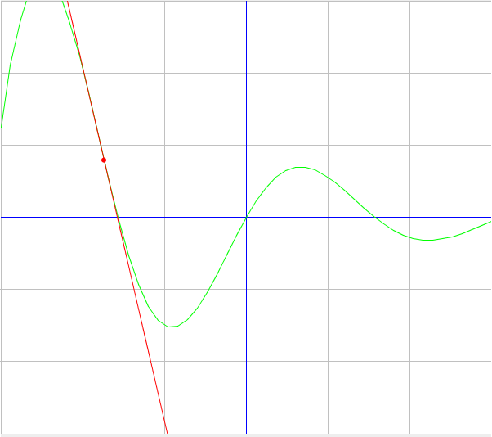

What do you notice about these lines?
The lines you have drawn are called “tangent lines”. They touch the curve at exactly one point. The “derivative” is all about finding the gradients of these tangent lines.

The gradient of a line is constant. The gradient of a curve changes.

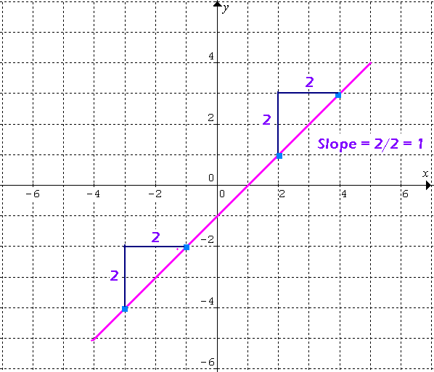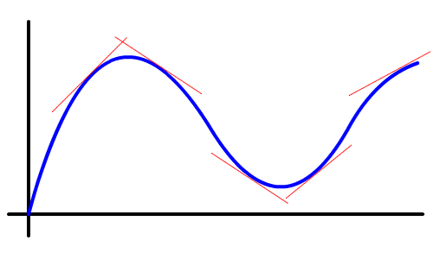

Draw the tangent line through each point on the curve. Identify each gradient as positive, negative, or zero.

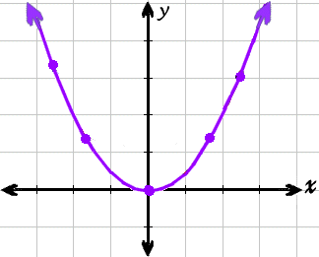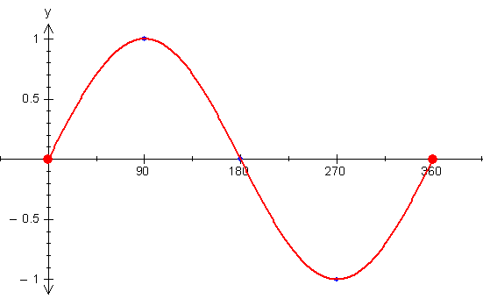

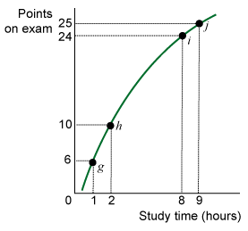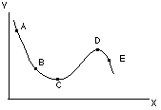
Gradients and derivatives are simply rates of change of a particular function $f(x)$.

They can be written in several ways: $\frac{dy}{dx}$ $y'$ $f'(x)$

Rates of change can be positive, zero, or negative.

In addition, they can also be constant, increasing, or decreasing.

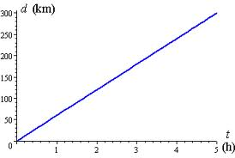
$f(x)$ is at a rate.

The rate of change $\frac{dy}{dx}$ is and .

$f(x)$ is at a rate.

The gradient $f'(x)$ is and .

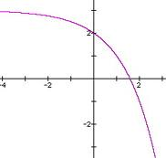

$f(x)$ is at a rate.

The rate of change $\frac{dy}{dx}$ is and . .

Write a time-series graph for each of these containers as they fill with water.

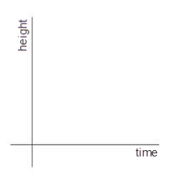
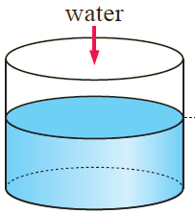

Explanation:

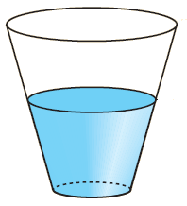
Explanation:

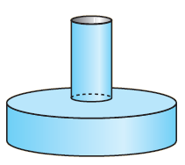
Explanation:

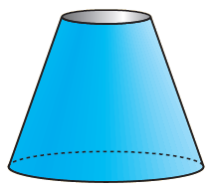
Explanation:
One way to find the gradient $f'(x)$at a given point on a curve is to first find the gradient between two points on the curve. Then we move the points closer and closer together and see what happens to the gradient.
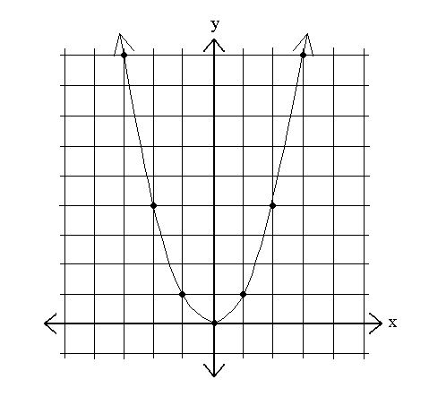
For example, let’s say we want to find the gradient of the tangent line on $y=x^{2}$ through $(2,4)$

We could find the gradient between the point $(2,4)$ and other points closer and closer to $\left(2,4\right).$

Gradient between (0 , ____ ) and $\left(2,4\right):$

Gradient between (1 , ____ ) and $\left(2,4\right):$

Gradient between (1.5 , ____ ) and $\left(2,4\right):$

Gradient between (1.9 , ____ ) and $\left(2,4\right):$

Gradient between (1.999 , ____ ) and $\left(2,4\right):$

So, what do you think the gradient $f'(x)$probably is at the point $(2,4)$?

Next class we will learn how to exactly find the gradient $f'(x)$ at any given point.
IB Math Studies Year 2

6.1 Introduction to Differentiation - Practice

1. Draw the tangent line through each point.
Describe the gradient $f^{'}\left(x\right)$at each point as positive, negative, or zero.

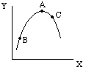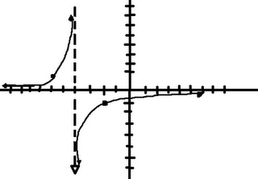
N
M

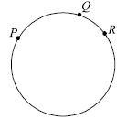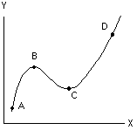

2. Draw each horizontal tangent line. There are 4 in each graph.

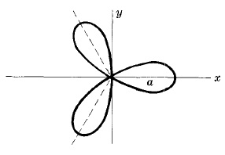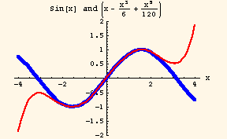
Week 13: Tuesday 19 November
Chapter 6: Calculus
Topic: 6.2 The Gradient Function
IB Syllabus: 7.2
Lesson Obj: Students find the first derivative of polynomial functions using the power rule.
Students will find the gradient of a tangent line for given values of x and f(x).

Review and Intro:
- Vocab on board: derivative, gradient, tangent. Homework questions.
- Review power rule from videos with positive exponents.
Core Lesson:
- Negative exponents.
- Constant rule – use GDC.
- Derivative intuition Khan Academy with students at the SmartBoard
- http://www.khanacademy.org/math/calculus/differential-calculus/visualizing-derivatives-tutorial/e/derivative_intuition
Check for Understanding:
- Check student work and discussion throughout.
- QUIZ next period

Assignment: Students will complete:
6.2 The Gradient Function
Negative Exponent Intuition
Negative and Positive Exponents
Practice: Simplifying Expressions with Exponents

Graphs of Functions and their Derivatives
Where a Function is Not Differentiable
Identifying a Function's Derivative
Which Function is the Derivative?
Practice: Graphs of Functions and Their Derivatives

IB Math Studies Year 2

6.2 The Gradient Function

Practice what you learned last night with the Power Rule:

If $f\left(x\right)=ax^{n}$ then $f^{'}\left(x\right)=nax^{n-1}$

$$f\left(x\right)$$ | $$\frac{dy}{dx}$$ | $f'\left(x\right)$ at a value
$$8-5x+4x^{6}$$ |  | $f^{'}\left(2\right)=$
$$3x^{2}+5x^{3}$$ |  | $f^{'}\left(-1\right)=$
$$9x^{2}-\frac{x}{5}+\frac{1}{2}$$ |  | $f^{'}\left(4\right)=$
$$x(2x+3)$$ |  | $f^{'}\left(1\right)=$
$${\left(2x-3\right)}^{2}$$ |  | $f^{'}\left(0.5\right)=$
$$-\frac{x^{4}}{2}+3x^{3}-2x+7$$ |  | $f^{'}\left(2\right)=$
13 |  | $$f^{'}\left(3\right)=$$
$$x$$ |  | $$f^{'}\left(-5\right)=$$
 | $$5x^{4}$$ | $f^{'}\left(2.5\right)=$
 | $$6$$ | $f^{'}\left(3\right)=$

In the past, you may have studied negative exponents. They are used to represent variables that are in the denominator of a fraction.

Fraction form | Power form | Fraction form | Power form
$$\frac{1}{x^{2}}$$ |  |  | $$2x^{-1}$$
$$\frac{3}{x^{2}}$$ |  | $$\frac{2}{3x^{3}}$$
$$\frac{1}{{2x}^{2}}$$ |  |  | $$4x^{-3}$$
$$\frac{1}{x}$$ |  | $$\frac{4}{x}$$

The derivatives of these types of functions are also found using the power rule. First rewrite the function using negative exponents. Then follow the same rule: Multiply by the exponent and subtract one from the exponent.

Original  function | Rewrite the Function | Take the derivative | Rewrite the derivative
$$f\left(x\right)$$  Fraction form | $$f\left(x\right)$$  Power form | $$f'\left(x\right)$$  Power form | $$f'\left(x\right)$$  Fraction form
$$\frac{1}{x}$$
$$-\frac{1}{x^{2}}$$
$$\frac{5}{2x^{3}}$$
$$-\frac{6}{x^{4}}$$
$$x^{2}-\frac{2}{x}$$
$$2x+\frac{1}{x^{2}}$$
$$4x^{3}-\frac{x^{2}}{4}+\frac{4}{x^{2}}$$

We also have to find the derivative of a constant function, such as $f(x)=3$.
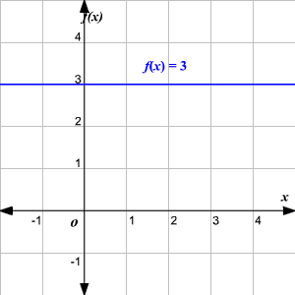
The graph of $f(x)=3$ is shown here.

What is its gradient?

What is its derivative?

Graph $f(x)=2$ and $f(x)=-1$.

What are their gradients?

What are their derivatives?

Based on this information, what is the derivative of any constant function?

If $f(x)=c$, then $f'(x)=$ .

IB Practice

1. Differentiate $f\left(x\right)=6x^{3}+10x^{2}-3x+7.$

2. Find $\frac{dy}{dx}$if $f\left(x\right)=3x^{2}-\frac{4}{x^{3}}+1$.

3. Find $f^{'}\left(-2\right)$ if $f\left(x\right)=6x^{2}+6$

Derivative Intuition: If you know a function, can you sketch its derivative?

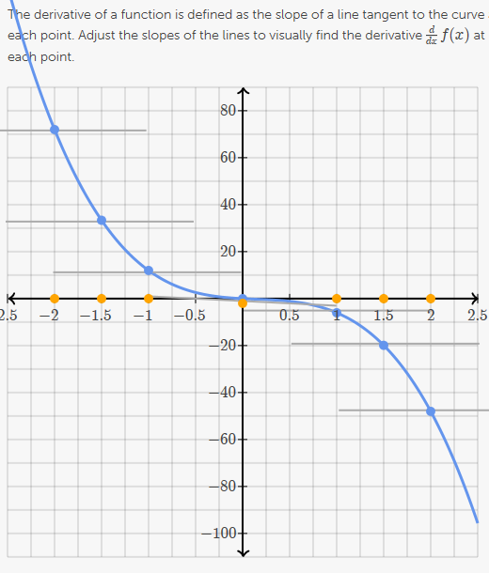
Week 14: Wednesday 15 November
Chapter Six: Introducing Differential Calculus
Topic: 6.2 The power rule
IB Syllabus: 7.2
Lesson Obj: Students find use the power rule to find derivatives.
Students will match graphs of functions with graphs of their derivatives.
Students will find values of functions and derivatives at given points.

Review and Intro:
- Vocab on board: derivative, gradient, tangent. Homework questions.
- QUIZ
- Correct quiz in class
Core Lesson:
- Derivative card game (this took a long time for most students)
Check for Understanding:
- Check student progress throughout

Assignment: Students will watch videos and complete online exercises:

Finding a slope at a point
Example 1 Example 2
Practice: Derivatives 1

Intuitively drawing the derivative of a function
Intuitively drawing the antiderivative of a function
Visualizing derivatives exercise
Practice: Visualizing Derivatives

IB Practice

Let $f(x)=2x^{3}+3x^{2}-12x$

a) i) Find the derivative of $f(x)$.

ii) Hence, calculate $f'(-1)$.

iii) Verify your answer to aii) using the calculator.

b) Fill in the table of values below

$$x$$ | -3 | -2 | -1 | 0 | 1 | 2
$$f(x)$$
$$f'(x)$$

c) On graph paper, graph $f(x)$ for $-3≤x≤2$ and $-10≤y≤25$. Use 2 cm to represent 1 unit on the $x$-axis and 1 cm to represent 2 units on the $y$-axis.

d) Use your GDC to write down the equation of the tangent line to $f(x)$ at $x=-1$.

e) On your graph, accurately draw the tangent line to $f(x)$ at $x=-1$.

f) Find the second point of intersection between the tangent line and $f(x)$.

Week 14: Wednesday 27 November
Chapter Six: Introducing Differential Calculus
Topic: 6.3 The Gradient of a Curve at a Given Point
IB Syllabus: 7.3
Lesson Obj: Students find the slope of the tangent line to a curve at a given point.

Review and Intro:
- Vocab on board: derivative, gradient, tangent. Homework questions.
- QUIZ
Core Lesson:
- Gradient function -- exploration
- IB Practice w/graph paper
- Nov 2011 P1 Q14
- Calculaughs 24-25
Check for Understanding:
- Check student work and discussion throughout.
- QUIZ next period

Assignment: Students will watch online videos and complete guided outline.

Finding the equation of the tangent line
Example 1 Example 2

IB Math Studies Year 2

6.3 The Gradient of a Curve at a Given Point

1. a) On the grid below, accurately draw $f\left(x\right)=6x^{2}+1$ for $-2.5≤x≤2.5$
and $-40≤y≤40$.
40
-40
-3
-2
-1
3
2
1

b) Find the derivative $f'\left(x\right)$.

c) Use the derivative to calculate the gradients of $f(x)$ at the following points. Show your work. Plot each point on the graph above.

$$x$$ | $$-2$$ | $$-1.5$$ | $$-1$$ | $$0$$ | $$1$$ | $$1.5$$ | $$1$$
$$f'(x)$$

d) Connect the points of $f'(x)$.
What is the relationship between the two functions?

2. a) On the grid below, accurately draw $f\left(x\right)=-4x^{3}$ for $-2.5≤x≤2.5$
and $-70≤y≤70$.

-3
-2
-1
-70
70
3
2
1

b) Find the derivative $f'\left(x\right)$.

c) Use the derivative to calculate the gradients of $f(x)$ at the following points. Show your work. Plot each point on the graph above.

$$x$$ | $$-2$$ | $$-1.5$$ | $$-1$$ | $$0$$ | $$1$$ | $$1.5$$ | $$1$$
$$f'(x)$$

d) Connect the points of $f'(x)$.
What is the relationship between the two functions?

IB Math Studies Year 2

Guided outline for 6.4 The Tangent Line

Notes for Example 1:

Find the equation of the line tangent to $f\left(x\right)=x^{3}-2x$ at the point $(2,4)$.
$f(x)=$

$$f'(x)=$$

$f'(2)=$ What does $f'(2)$ give us?

Use the point-slope formula (or any other formula) to find the tangent line:

Verify your tangent line equation on the calculator!

Notes for Example 2:

Find the equation of the line tangent to $f\left(x\right)={2x}^{2}+3x-2$ when $x=0$.
$f(x)=$

$$f'(x)=$$

$f'(0)=$ What does $f'(0)$ give us?

Use the point-slope formula (or any other formula) to find the tangent line:

Verify your tangent line equation on the calculator!
Practice 1:

Find the equation of the line tangent to $f\left(x\right)=5x-3x^{2}$ at the point $(-1,-8)$.
$f(x)=$

$$f'(x)=$$

$f'(-1)=$ What does $f'(-1)$ give us?

Use the point-slope formula (or any other formula) to find the tangent line:

Verify your tangent line equation on the calculator!

Practice 2:

Find the equation of the line tangent to $y=6x-\frac{8}{x^{2}}$ when $x=-2$.
$f(x)=$

$$f'(x)=$$

$f'(-2)=$ What does $f'(-2)$ give us?

Use the point-slope formula (or any other formula) to find the tangent line:

Verify your tangent line equation on the calculator!
Week 15: Monday 2 December
Chapter Six: Introducing Differential Calculus
Topic: 6.4 The Tangent Line
IB Syllabus: 7.3
Lesson Obj: Students will find the gradient of a tangent line for given values of x and f(x).
Students will find values of x that have horizontal tangent lines.
Students will find the equation of a tangent line of a function at a given point

Review and Intro:
- Vocab on board: derivative, gradient, tangent. Homework questions.
- QUIZ
Core Lesson:
- Tangent line -- exploration
- Use GDC.
Check for Understanding:
- Check student work and discussion throughout.

Assignment: Students will complete online videos and practice:
Perpendicular line slope
Perpendicular lines 2
Practice: Equations of parallel and perpendicular lines

IB Math Studies Year 2

6.4 The Tangent Line

Remember that the derivative gives you the gradient of the tangent line at any point along a function. We can use this idea to solve different kinds of problems.

1. Consider the function $f\left(x\right)=2x^{2}-4x+1$. Find the equation of the tangent line at each value below. Show your work by hand; then verify on the graphing calculator.

a) $x=0$

b) $x=1$

2. Find the values of $x$ where the function $g\left(x\right)=x^{3}-\frac{3}{2}x^{2}-18x-1$ has a horizontal tangent line.

2. Let $y=x^{3}+3x^{2}+3x+4.$

a) Find $\frac{dy}{dx}$.

b) Find the gradient of the curve when $x=-2$.

c) Is the function $y$ increasing or decreasing when $x=-2$?

d) Find the value(s) of $x$ when the gradient of the curve is 3.

e) Find the value(s) of $x$ when the curve has a horizontal tangent line.

3. A function is given as $y=ax^{2}+bx+6.$

a) Find $\frac{dy}{dx}$.

b) The gradient of this function is 2 when $x$ is 6.
Write an equation in terms of $a$ and $b$.

c) The point $(3,-15)$ lies on the graph of the function.
Find a second equation in terms of $a$ and $b$.

d) Use your GDC and your equations from parts b) and c) to find the values of $a$ and $b$.

Week 15: Wednesday 4 December
Chapter Six: Introducing Differential Calculus
Topic: 6.4 The Normal Line
IB Syllabus: 7.3
Lesson Obj: Students find equation of a normal line to a curve through a given point.

Review and Intro:
- Vocab on board: derivative, gradient, normal. Homework questions.
- SmartBoard example of tangent and normal lines
Core Lesson:
- Normal line -- exploration
- Verify on GDC.
Check for Understanding:
- Check student work and discussion throughout.

Assignment: Students will complete online videos and guided outline
Applications of Differentiation
Calculus: Applications of Rates of Change

IB Math Studies Year 2

6.4 The Normal Line

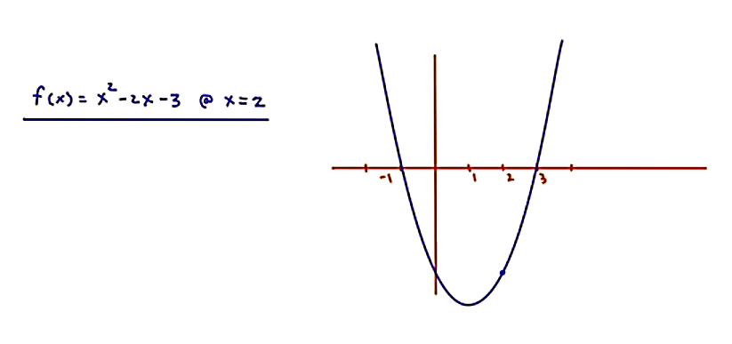

For each function:

a) Find the equation of the tangent line through the given point
b) Find the equation of the normal line through the given point
c) Sketch the function, the tangent line, and the normal line.

Show all your work in your notebooks by hand. Then verify on the GDC.

1. $f\left(x\right)=2x^{2}+3x-5$ at the point $(2,9)$

2. $g\left(x\right)=\frac{2}{3}x^{3}+\frac{5}{2}x^{2}+2x+1$ at the point where $x=3$

3. $y=x+\frac{6}{x}$ at the point where $x=-1$

4. $y=x^{2}-8x+21$ where the gradient is zero

IB Math Studies Year 2

Guided outline for 6.5 Rates of Change

Applications of Differentiation Video

Rate of change of $y$ with respect to $x$ =

Rate of change of volume with respect to time =

Rate of change of area with respect to temperature =

Example 1: $P=3r^{2}+\frac{5}{r}$

Example 2: $N=250+100t+50t^{3}$

a) How many bacteria are there after 5 hours?

b) What is the rate of change of $N$ with respect to $t$?

c) What is happening to the colony of bacteria after 2 hours? after 10 hours?

Explain the difference between instantaneous rate of change and average rate of change.

Calculus: Applications of Rates of Change

The cost of producing $x$ gadgets is given by $C\left(x\right)=70x+0.01x^{3}$.

What does the 70 represent in the cost?

What does the 0.01 represent in the cost?

Find the derivative of the cost function.

What does this “rate of change” mean in the real world?

What is happening to the cost when we produce 10 gadgets?

IB Math Studies Year 2

Guided practice for 6.5 Rates of Change

The volume of water in a container, $V cm^{3},$ is given by the formula $V=300+2t-t^{2},$
where $t$ is time measured in seconds.

a) Sketch and label a graph of this function for $0≤x≤20$ and $0≤y≤500.$

b) Find $\frac{dV}{dt}.$What does $\frac{dV}{dt}$ represent?

c) What units are used for $\frac{dV}{dt}$?

d) What is the volume of the water when $t=3$?

e) At what rate is the volume changing when $t=3$?

A company mines copper, where the mass of copper, x, is measured in thousands of tonnes. The company’s profit, P, measured in millions of dollars, depends on the amount of copper mined.

The profit is given by the function $P\left(x\right)=2.3x-0.05x^{2}-12.$

a) What does the 2.3 represent in the function?

b) Find $P(0)$ and $P(6)$. Interpret those results.

c) Find $\frac{dP}{dx}$. What does $\frac{dP}{dx}$ represent?

d) Find the value of $P$ and $\frac{dP}{dx}$ when $x=20$. Interpret these results.

e) Find the value of $x$ for which $\frac{dP}{dx}=0.$ What is happening at that value?
Week 16: Sunday 8 December
Chapter 6: Introducing Differential Calculus
Topic: 6.5 Rates of Change
IB Syllabus: 7.1
Lesson Obj: Students will solve calculus applications related to rates of change.

Review and Intro:
- Homework questions.
- QUIZ / Review quiz individually while students work on Rate of Change problems
Core Lesson:
- Students complete rate of change problems 1-9
Check for Understanding:
- Check Student work throughout

Assignment: Students will complete guided outlines and practice for:
First Derivative Test - What is it?
First derivative test

IB Math Studies Year 2

6.5 Rates of Change

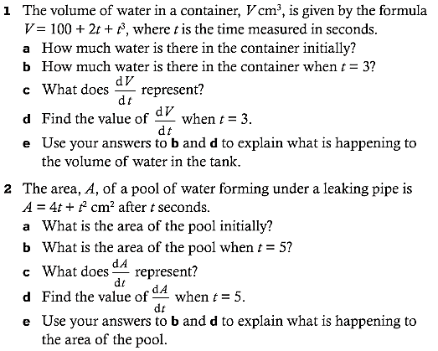
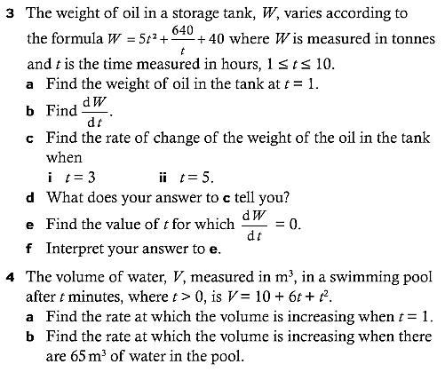
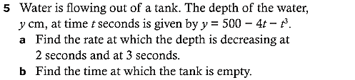
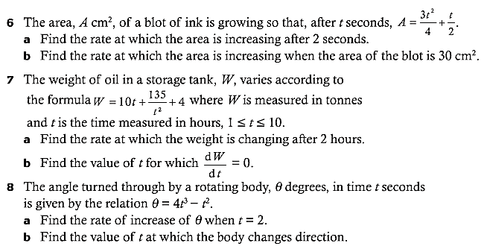
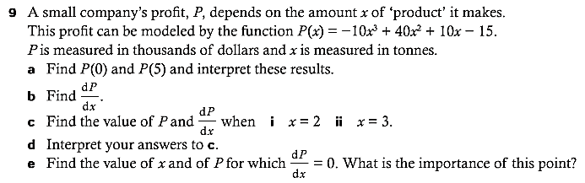

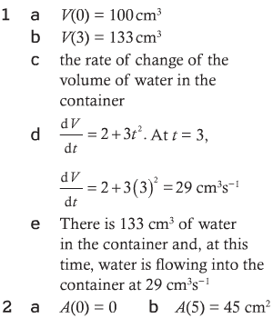
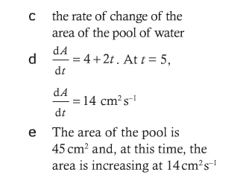
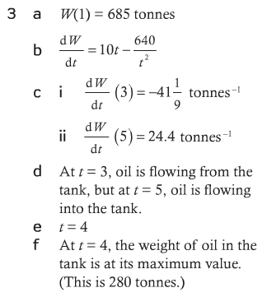
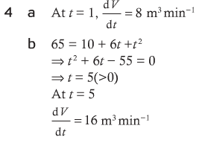
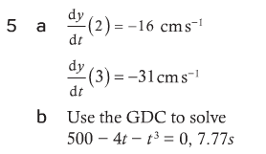
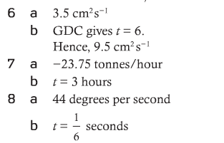
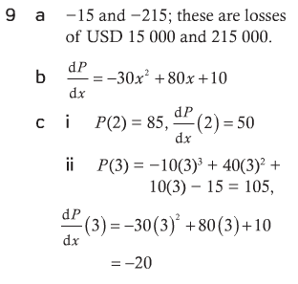

IB Math Studies Year 2

Guided outline for 6.6 Local Minimum and Maximum Points

First Derivative Test – What is it?
http://www.youtube.com/watch?v=H9t0FJBO4O4

When do we have a local minimum? | Diagram
When do we have a local maximum? | Diagram
When do we have neither a local minimum nor a local maximum? | Diagrams

How do we know when we have a critical point?

First derivative test
http://www.youtube.com/watch?v=xNjlgXNp2jo

Summarize the first derivative test in the chart below:

Condition | Critical point | Diagram
$f\left(x\right)=x^{4}-2x^{2}.$

Step 1: Use the first derivative to find the critical points.

Step 2: Use the first derivative test to identify function behavior.

Step 3: Identify each critical point.

IB Math Studies Year 2

Guided practice for 6.6 Local Minimum and Maximum Points

Use the first derivative test to identify the local extrema of $f\left(x\right)=x^{2}-4x+9$.

Step 1: Use the first derivative to find the critical points.
[You should get $x=2$…]

Step 2: Use the first derivative test to identify function behavior.

$x=2$

Step 3: Identify each critical point.

IB Math Studies Year 2

Guided practice for 6.6 Local Minimum and Maximum Points

Use the first derivative test to identify the local extrema of $f\left(x\right)=x^{3}-27x+10$.

Step 1: Use the first derivative to find the critical points.
[You should get $x=3$ and $x=-3$…]

Step 2: Use the first derivative test to identify function behavior.

$x=-3$ $x=3$

Step 3: Identify each critical point.

Week 16: Tuesday 10 December
Chapter Six: Introducing Differential Calculus
Topic: 6.6 Local maximum and minimum points
IB Syllabus: 7.4
Lesson Obj: Students will identify the intervals where a function is increasing or decreasing.
Students will sketch a function based on derivative values.
Students will solve problems related to the maximum and minimum of functions.

Review and Intro:
- Homework questions.
- Derivative tells us gradient. Gradient tells us whether the function is increasing or decreasing.
- Therefore, the derivative also tells us where the function is increasing or decreasing.
- Two intro problems – derivative to function.
Core Lesson:
- Student worksheets 1-5.
Check for Understanding:
- Check student progress throughout.

Assignment: Students will watch videos and complete guided outlines.
Optimizing box volume graphically
Optimizing box volume analytically
Minimizing the cost of a storage container

Additional problems if necessary:

USE $f\left(x\right)=x^{3}-3x^{2}+3x-9$
Students do a line with positive slope equaling the derivative. Analyze. Work to drawing the function.
Explore
$$f\left(x\right)=3x^{2}-12x$$
$$f\left(x\right)=-\frac{2}{3}x^{3}+2x^{2}+6x+3$$
Use graph AND derivative to create intervals chart.

IB Math Studies Year 2

6.6 Local maximum and minimum points

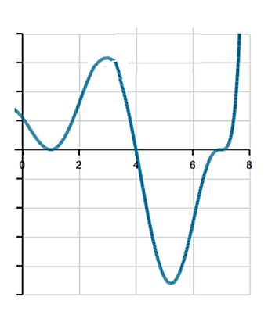
Critical values can occur wherever .

$x$-value(s)
$$f'(x)$$
$$f(x)$$
sketch

The graph below shows the derivative $f'(x)$ of an unknown function.
Use this information to draw a possible graph of the unknown function.

Graph of $f(x)$ Graph of $f'(x)$

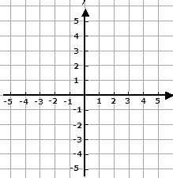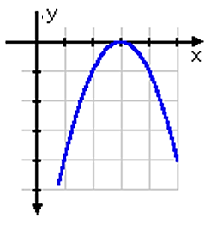

Critical values can occur wherever .

$x$-value(s)
$$f'(x)$$
$$f(x)$$
sketch

IB Math Studies Year 2

6.6 Local maximum and minimum points

1. Using the graph of $f(x)$, given below, answer the following questions.

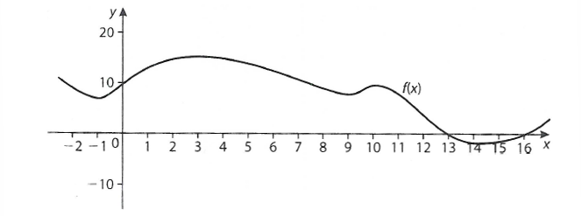

a) Identify the values for which $f'(x)=0$.

b) Identify the intervals for which $f'(x)>0$.

c) Identify the intervals for which $f'(x)<0$.

2. Sketch a curve which meets the following criteria:

$x-$value / interval | $$f^{'}(x)$$
$$(-∞,1]$$ | $f^{'}(x)$>0
$$1$$ | $$f^{'}\left(x\right)=0$$
$$[1, 3]$$ | $$f^{'}\left(x\right)<0$$
$$3$$ | $$f^{'}\left(x\right)=0$$
$$[3,∞)$$ | $$f^{'}\left(x\right)>0$$

3. Create a derivative interval chart [as in problem 2] for this function.

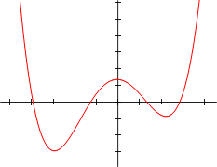
4. Sketch a curve which meets the following criteria:

$x-$value / interval | $$f^{'}(x)$$
$$(-∞,1]$$ | $f^{'}(x)$<0
$$1$$ | $$f^{'}\left(x\right)=0$$
$$[1, 3]$$ | $$f^{'}\left(x\right)>0$$
$$3$$ | $$f^{'}\left(x\right)=0$$
$$[3,5]$$ | $$f^{'}\left(x\right)<0$$
$$5$$ | $$f^{'}\left(x\right)=0$$
$$[5,7]$$ | $$f^{'}\left(x\right)>0$$
$$7$$ | $$f^{'}\left(x\right)=0$$
$$[7,∞]$$ | $$f^{'}\left(x\right)>0$$

5. Consider the function $f\left(x\right)=3x+\frac{12}{x^{2}}$.

a) Differentiate $f(x)$ with respect to $x$. [3]

b) Calculate $f'(x)$ when $x=1$. [2]

c) Use your answer to part b) to decide whether the function,
$f$, is increasing or decreasing at $x=1$. Justify your answer. [2]

d) Solve the equation $f^{'}\left(x\right)=0$. [3]

e) The graph of $f$ has a local minimum at point $P$.
Let $T$ be the tangent to the graph of $f$ at $P$.

i) Write down the coordinates of $P$. [2]

ii) Write down the gradient of $P$. [1]

iii) Write down the equation of $T$. [2]

f) Sketch the graph of the function $f$, for $-3≤x≤6$ and $-7≤y≤15.$
Indicate clearly the point $P$ and any intercepts of the curve with the axes. [4]

g) i) On your graph draw and label the tangent $T$. [1]

ii) $T$ intersects the graph of $f$ at a second point. [2]
Write down the $x$-coordinate of this point of intersection.

IB Math Studies Year 2

6.7 Using Differentiation in Modeling: Optimization

Optimizing box volume graphically
http://www.khanacademy.org/math/calculus/derivative_applications/calc_optimization/v/optimizing-box-volume-graphically

Sketch of the box: Volume function:

Graph of the volume function:

Optimizing box volume analytically
http://www.khanacademy.org/math/calculus/derivative_applications/calc_optimization/v/optimizing-box-volume-analytically

Minimizing the cost of a storage container
http://www.khanacademy.org/math/calculus/derivative_applications/calc_optimization/v/minimizing-the-cost-of-a-storage-container

A rectangular storage container with an open top needs to have a volume of 10 m³.
The length of its base is twice the width. Material for the base costs $10 per square meter. Material for the sides costs $6 per square meter. Find the cost of the material for the cheapest container.

Sketch of the box: Cost function using $x$ and $h$:

Express $h$ as a function of $x$: Substitute $h$ into the cost function:

Optimize: Find the critical points of the cost function (Ignore $C^{''}\left(x\right)$)

Weeks 16-17: Thursday 12 December / Monday 6 January / Wednesday 8 January
Chapter Fourteen: Calculus
Topic: 6.7 Modeling with Calculus
IB Syllabus: 7.5
Lesson Obj: Students will apply calculus to max/min problem.
Students will sketch a function based on derivative values.

Review and Intro:
- Homework questions.

DAY 1: Volume and Surface Area
- Worksheets 1-4

DAY 2: Mixed
- Worksheets 5-9

DAY 3: Mixed
- QUIZ
- Worksheets 10-13
Assignment: Students will study for test on Calculus

IB Math Studies Year 2

6.7 Modeling with Calculus – Perimeter, Area, Volume, and Surface Area

1. A closed box has a square base of side $x$ and height $h$.

a) Write down an expression for the volume, $V$, of the box.
b) Write down an expression for the total surface area, $A$, of the box.

The volume of the box is 1000 cm³.

c) Express $h$ in terms of $x$.
d) Use b) and c) to show that $A=4000x^{-1}+2x^{2}$.
e) Find $\frac{dA}{dx}$.
f) Calculate the value of $x$ that gives a minimum surface area.
g) Find the surface area for this value of $x$.

2. Ben has 200 metres of electric fence. With this fence he creates a rectangular enclosure.

a) Write an expression for the perimeter of the enclosure in terms of its length, $l$, and width, $w$.
b) Write an expression for the length, $l$, in terms of the width, $w$.
c) Use your expression from part b) to write an expression for the area, $A$, of the enclosure in terms of its width only.
d) Find $\frac{dA}{dw}$.
e) Find the dimensions of the enclosure that create the maximum
possible area.
f) What is the maximum possible area Ben can close with his electric fence?

3. A rectangular piece of card measures 24 cm by 9 cm. Equal squares of length $x$ cm are cut from each corner of the card as shown in the diagram below. What is left is then folded to make an open box, of length $l$ cm and width $w$ cm.
a) Write expressions, in terms of $x$, for
i) the length, $l$
ii) the width, $w$
b) Show that the volume ($V m^{3}$) of the box is given by
$V=4x^{3}-66x^{2}+216x.$
c) Find $\frac{dV}{dx}$.
d) i) Find the value $x$ which gives the maximum volume of the box.
ii) Calculate the maximum volume of the box.
4. A farmer has a rectangular enclosure with a straight hedge running down one side. The area of the enclosure is 162 m². He encloses this area using $x$ meters of the hedge on one side as shown on the diagram below.
a) If he uses $y$ meters of fencing to complete the enclosure,
show that $y=x+\frac{324}{x}$.

The farmer wishes to use the least amount of fencing.

b) Find $\frac{dy}{dx}.$
c) Find the value of $x$ which makes $y$ a minimum
d) Calculate this minimum value of $y$.
e) Using $y=x+\frac{324}{x}$ find the values of $a$ and $b$ in the following table.
f) Draw an accurate graph of this function using a horizontal scale starting at 0 and taking 2 cm to represent 10 meters, and a vertical scale starting at 30 with 4 cm to represent 10 meters.
g) Write down the values of $x$ for which $y$ increases.

IB Math Studies Year 2

6.7 Modeling with Calculus – Mixed IB Paper 2 Problems

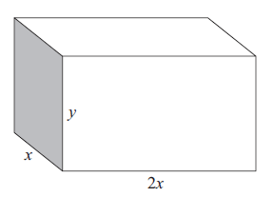
5. A shipping container is to be made with six rectangular faces, as shown in the diagram.
The dimensions of the container are

length $2x$
width $x$
height $y$.

All of the measurements are in metres.
The total length of all twelve edges is 48 metres.

a) Show that $y=12-3x$. [3]

b) Show that the volume $V$ m³ of the container is given by
$V=24x^{2}-6x^{3}$ [2]

c) Find $\frac{dV}{dx}$. [2]

d) Find the value of $x$ for which $V$ is a maximum. [3]

e) Find the maximum volume of the container. [2]

f) Find the length and height of the container for which the volume is a maximum. [3]

The shipping container is to be painted. One litre of paint covers an area of 15 m². Paint comes in tins containing four litres.

g) Calculate the number of tins required to paint the shipping container. [4]
6. The length of the base of a cuboid is twice the width $x$, and its height is
$h$ centimetres, as shown in the diagram below. Its total surface area is
$A$ cm² and its volume is $V$ cm³.

a) Show that $A=4x^{2}+6xh$. [2]

b) If $A=300$, find an expression for $h$, in terms of $x$. [2]

c) If $A=300$, show that the volume is $V=100x-\frac{4}{3}x^{3}$ . [2]

d) i) Find $V^{'}(x)$.
ii) Solve $V^{'}\left(x\right)=0$.
iii) Find the maximum volume.
iv) What is the height of the cuboid when the volume is maximized? [7]

7. The function $f(x)$ is given by $f\left(x\right)=x^{3}-3x^{2}+3x$, for $-1≤x≤3.$

a) Differentiate $f(x)$ with respect to x. [2]

b) Copy and complete the table below. [3]

c) Draw an accurate sketch of $f(x)$, labeling all critical points. [3]

d) Write down the equation of the tangent line to the curve at
the point $(3,9)$. [1]

8. Consider the function $f\left(x\right)=2x^{3}-3x^{2}-12x+5.$

a) i) Find $f^{'}\left(x\right).$ [2]

ii) Find the gradient of the curve $f(x)$ when $x=3.$ [2]

b) Find the $x$-coordinates of the points on the curve where the
gradient is equal to $-12$. [3]

c) i) Calculate the x-coordinates of the local maximum and
minimum points. [4]

ii) Hence, find the coordinates of the local minimum. [2]

d) For what values of $x$ is $f(x)$ increasing? [2]

9. Consider the function $f\left(x\right)=x^{3}-4x^{2}-3x+18$.

a) i) Find $f^{'}\left(x\right).$ [2]

ii) Find the coordinates of the maximum and minimum
points of the function. Justify your answers using$f^{'}\left(x\right).$ [8]

b) Find the values of $f(x)$ for $a$ and $b$ in the table below. [2]

c) Using a scale of 1 cm for each unit on the $x$-axis and 1 cm for each 5 units on the $y$-axis, draw the graph of $f(x)$ for
$-3≤x≤5$. Label clearly. [5]

d) Within the interval $-3≤x≤5$, state all intervals where the gradient of the curve at any particular point is negative and positive. [3]

IB Math Studies Year 2

6.7 Modeling with Calculus – Mixed IB Paper 2 Problems

10. The number of balloons sold each year by the 123 Balloon Company can be approximated by the formula

$$B\left(x\right)=0.0104x^{5}-0.3058x^{4}+3.099x^{3}-12.299x^{2}+16.983x$$

where $B(x)$ is the number of balloons in the millions and $x$ is the number of years since 1996.

a) How many balloons did the company sell in 2007?

b) Find $B'(x)$.

c) What was the rate of change in the number of balloons being sold in the year 2007 to the nearest hundred thousand?

11. The number of users of a particular social networking website can be modelled by using the formula

$$N\left(x\right)=0.074x^{3}-1.46x^{2}+8.58x$$

where $N(x)$ is the number of users in the thousands per day and $x$ is the number of months the website has been operational.

a) Fill in the table of values below.

$$x$$ | 0 | 2 | 4 | 6 | 8 | 10 | 12
$$N(x)$$

b) Draw an accurate sketch of $N(x)$ from $0≤x≤12.$

c) Find $N'(x)$.

d) Find the number of users being added during the second month.

12. The height (cm) of a daffodil above the ground is given by the function $h\left(w\right)=24w-2.4w^{2}$, where $w$ is the time in weeks after the plant has broken through the surface ($w≥0$).

a) Calculate the height of the daffodil after two weeks.

b) i) Find the rate of growth, $\frac{dh}{dw}$.
ii) The rate of growth when $w=k$ is 7.2 cm per week.
Find $k$.
iii) When will the daffodil reach its maximum height?
What height will it reach?

c) Once the daffodil has reached its maximum height, it begins to fall back towards the ground. Show that it will touch the ground after 70 days.

13. The cost of producing a mathematics textbook is $15.
It is then sold for $$x$.

a) Find an expression for the profit made on each book sold.

A total of $(100000-4000x)$ books is sold.

b) Show that the profit made on all the books sold is

$$P=160000x-4000x^{2}-1500000$$

c) i) Find $\frac{dP}{dx}$.
ii) Calculate the value of $x$ to make a maximum profit.

d) Calculate the number of books sold to make this maximum profit.

IB Math Studies Year 2

6.7 Modeling with Calculus – Rates of Change [ANSWERS]

10. a) $B\left(11\right)=0.0104{\left(11\right)}^{5}-0.3058{\left(11\right)}^{4}+3.099{\left(11\right)}^{3}-12.299{\left(11\right)}^{2}$
$+16.983\left(11\right)$
$=21,115,600$ balloons

b) $B^{'}\left(x\right)=0.052x^{4}-1.2232x^{3}+9.297x^{2}-24.598x+16.983$

c) The derivative in the year 2007 is $B^{'}\left(11\right)=4.59$ = 4,600,000 balloons

11. a) Fill in the table of values below.

$$x$$ | 0 | 2 | 4 | 6 | 8 | 10 | 12
$$N(x)$$ | 0 | 11.9 | 15.7 | 14.9 | 13.1 | 13.8 | 20.6
y = 1000s of users per day
10 20 30 40
b)
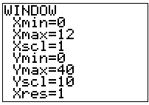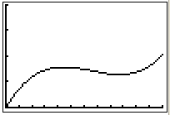
x = months

1 2 3 4 5 6 7 8 9 10 1112

c) $N^{'}\left(x\right)=0.222x^{2}-2.92x+8.58$

d) $N^{'}\left(2\right)=3,628$ users

12. a) $h\left(2\right)=24\left(2\right)-2.4{\left(2\right)}^{2}=38.4$ cm

b) i) $\frac{dh}{dw}=24-4.8w$.

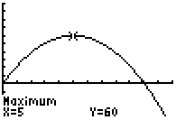
ii) Find when the derivative equals 7.2
$$h^{'}\left(k\right)=7.2 \\ 24-4.8k=7.2 \\ -4.8k=-16.8 \\ k=3.5$$
y = height (cm)
50 100

iii) Max height when $h^{'}\left(x\right)=0$:
x = weeks
1 2 3 4 5 6 7 8 9 10
$$24-4.8w=0 \\ 24=4.8w \\ 5=w$$
$h\left(5\right)=24\left(5\right)-2.4{\left(5\right)}^{2}=60$

c) From the graph, you can see that the height is zero when $x$ = 10.
But x is measured in weeks, so 10 weeks x 7 days = 70 days.

13. a) Profit on one item = revenue – cost = $x-15$

b) Profit on all items is (profit on one item) x (the number of items)

$$P=\left(x-15\right)\left(100000-4000x\right) \\ =100000x-4000x^{2}-1500000+60000x \\ =160000x-4000x^{2}-1500000$$
y = profit
50 100 150
c) i) $\frac{dP}{dx}=160000-8000x$
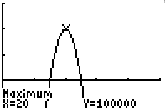
ii) Maximum where $\frac{dP}{dx}=0$.
x = books
10 20 30 40 50

$$160000-8000x=0 \\ 160000=8000x \\ 20=x$$

d) $P\left(20\right)=160000(20)-4000{(20)}^{2}-1500000=100000$

